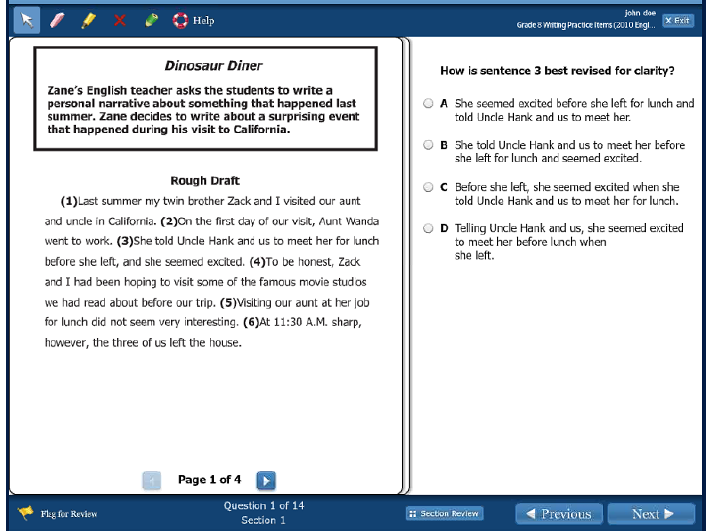

Clarity means _____________________________________________________________.

Explain why selected a certain letter over the other letters.

Highlight the transitions used in this paragraph.

Add an example of figurative language into the paragraph.

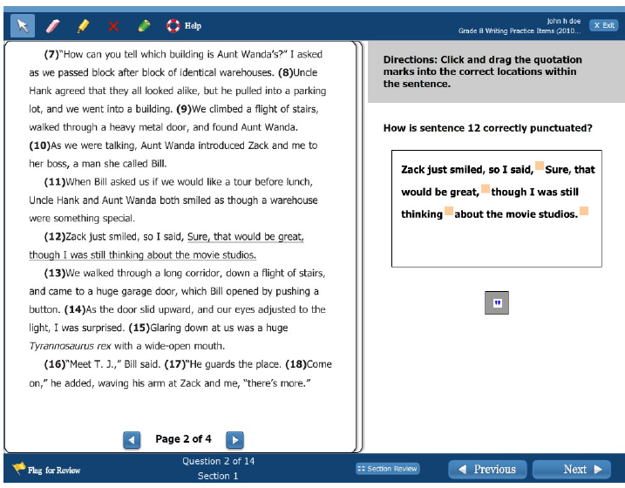

Add an example of figurative language into one of the paragraphs.

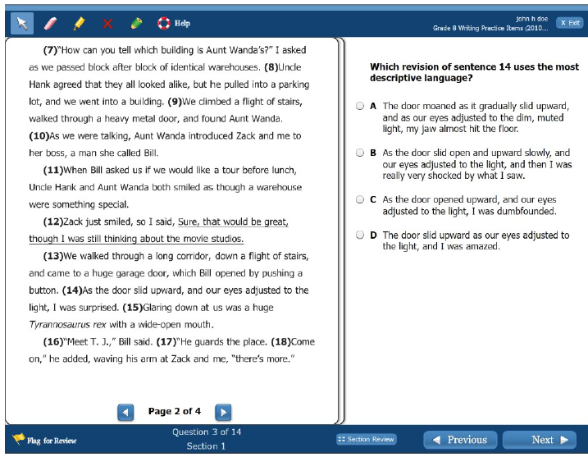

Find a complex sentence and label the dependent and independent clauses.

Are they punctuated correctly?

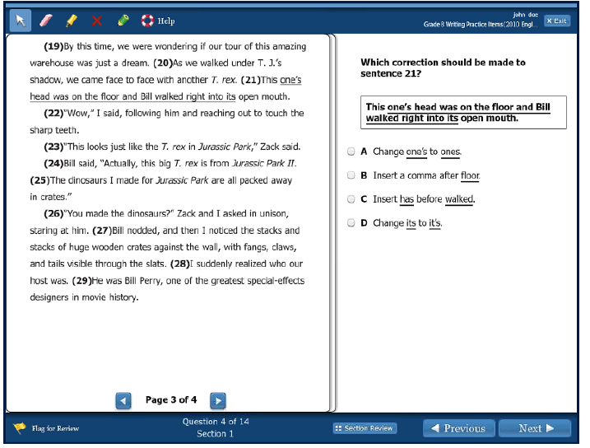

How could sentence 27 be rewritten so it is more descriptive and has vivid vocabulary?

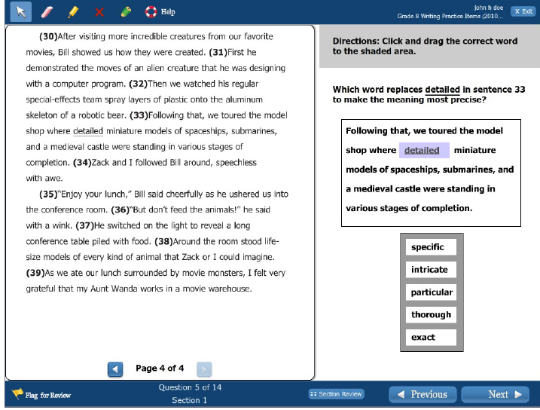

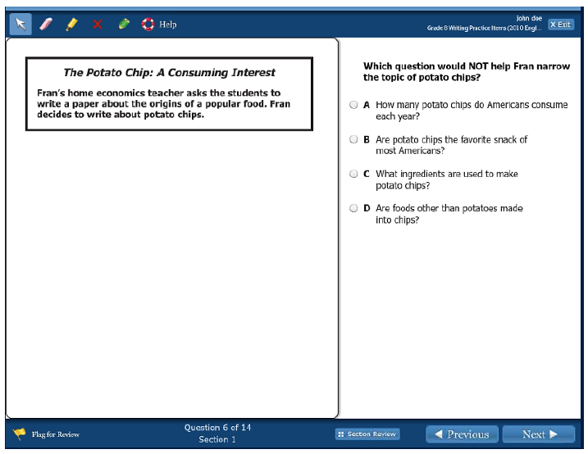

Expository or Persuasive?

Will this student have to do research?

If so, what are the steps she will have to follow?