Energizer # _____6_____: Parts of Speech: Adjectives 8.8.1
An adjective is a word used to describe a noun or a pronoun. An adjective describes what kind, which one, how much or how many?
Types of adjectives | Explanation | Examples?
demonstrative adjectives | point out a particular noun | This, that, those, these
proper adjectives | Formed from a proper noun and are always CAPITALIZED | Russian dressing, American furniture

Energizer # _____7_____: Parts of Speech: Adverbs 8.8.1
An adverb is a word that modifies a verb, an adjective, or another adverb. An adverb tells where, when, how, or to what extent (how much or how long).
Example: You should listen carefully to advice from experienced teachers.
carefully = adverb modifying the verb listen (How should you listen? Carefully)
Example: The team is extremely proud of its record.
extremely = adverb modifying the adjective proud (How proud was the team? Extremely proud)
Example: Elena finished the problem more quickly than I did.
quickly = adverb and more = adverb (How did Elena finish the problem? Quickly)
(How quickly did she finish it? More quickly)

Energizer 6 & 7 Review: Parts of Speech: Adjectives and Adverbs 8.8.1

Tips & Tricks
If you are not sure whether a word is an adjective or an adverb, ask yourself, “What does the word modify?”

If it modifies a noun or a pronoun, it must be an adjective.

ex. She gave us the daily report. (report is a noun, so daily must be an adjective)

If it modifies a verb, adjective, or another adverb, then it must be an adverb.

Ex. Alicia recently won the spelling bee. (won is a verb, so recently must be an adverb)

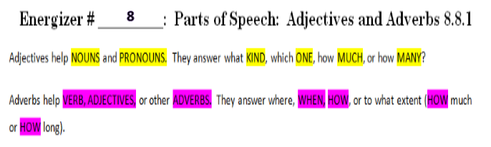
Energizer # _____9_____: Using Comparative and Superlative Degrees 8.8.6
Adjectives and adverbs may be used to compare things. In making comparisons, adjectives and adverbs take different forms:
- The comparative form of an adjective or adverb is used when comparing two things. Hint: When using the comparative form, you add –er to most one or two syllable words and you add more to three syllable words.
Example: The building is taller than that one.
taller = comparative form
Example: I ski more frequently than she does.
more frequently = comparative form
- The superlative form of an adjective or adverb is used when comparing more than two things. Hint: When using the superlative form, you add –est to most one or two syllable words and you add most to three syllable words.
Example: This building is the tallest one in the world.
tallest = superlative form
Example: Of the three of us, I ski most frequently.
most frequently = superlative form
Energizer # _____10_____: Prepositions 8.8.6
Prepositions are words that show position, direction, or how two words or ideas are related to each other.
Example: Raul hid under the stairs.
under = preposition (the relation to the stairs)

Example: Weather events occur even in outer space.
in = preposition (the relation to outer space)
Commonly Used Prepositions
aboard | before | in front of | past
about | below | inside | since
above | beneath | in spite of | through
according to | beside | instead of | throughout
across | besides | into | to
after | between | like | toward
against | but | near | under
along | by | next to | underneath
along with | down | of | until
amid | during | off | unto
among | except | on | up
around | for | on account of | upon
aside from | from | out | with
as of | in | out of | within
at | in addition to | over | without

Energizer # ____11______: Prepositional Phrases 8.8.6
You can use a preposition phrase as an adjective to describe either a noun or a pronoun. Adjectives answer what kind? how many? how much? or which one?
Example: The weather report on channel 13 predicts a cool night with clear skies.
on channel 13 = prepositional phrase (it answers which one?)
with clear skies = prepositional phrase (it answers what kind?)
You can also use a preposition phrase as an adverb to describe a verb, an adjective, or another adverb. Adverbs answer how? when? where? how long? how often? or how much?
Example: It hasn’t rained in Middleville for three weeks.
in Middleville = prepositional phrase (it answers where?)
for three weeks = prepositional phrase (it answers how long?)

